

PROJECT REPORT

Wisp



December 16, 2023

Strawhats

**Index**

|  |  |  |
| --- | --- | --- |
| **S. No** | **Content** | **Page No.** |
| **1** | **Introduction** | **2** |
| **2** | **Literature Study** | **2** |
| **3** | **Ideation and Proposed Solution** | **5** |
| **4** | **Novelty/Uniqueness** | **8** |
| **5** | **Social Impact/Customer Satisfaction** | **8** |
| **6** | **Business Revenue Generation Model** | **10** |
| **7** | **Scalability** | **11** |
| **8** | **References** | **12** |

1. **Introduction**

In the ongoing pursuit of sustainable practices, our world is witnessing a pivotal shift towards embracing a future powered by clean energy. In the Indian landscape, the rise of Electric Vehicles (EVs) is nothing short of exponential, creating a pressing need for an infrastructure that can keep pace with this transformative trend. Against this backdrop, envision a unique scenario where an innovative entrepreneur endeavours to address the burgeoning demand for charging stations in an unconventional manner – by integrating them within the private spaces of individuals.

Our solution strives to meet the charging needs of EV owners by establishing charging stations in residential settings, thus presenting a practical and efficient alternative to the scarcity of public charging infrastructure. Picture homes with ample space equipped with extra charging stations, seamlessly accessible through our user-friendly mobile app. This initiative not only aligns with the ethos of sustainable living but also envisions a collaborative community effort in propelling the electric vehicle movement forward. Join us in exploring this approach that not only meets the growing demands of EV charging but also fosters a future where clean energy is seamlessly integrated into the fabric of our daily lives.

1. **Literature Survey**

*2.1 EV Charging Infrastructure in India:*

India is working towards increasing the number of public EV charging stations, incentivizing private investment, and integrating renewable energy sources to create a reliable and efficient charging network [1]. As of March 2023, India has an active network of 934 public EV charging stations, with Delhi and Maharashtra having the largest number of charging stations [5]. However, there are still several challenges to EV adoption in the country, including slow deployment of charging infrastructure [9].

*2.2 Home-Based Charging Stations:*

Home-based charging stations are a convenient option for most EV owners, as they are customizable, save time, and can be done overnight [2]. In India, innovative solutions are being explored to meet the growing demand for charging stations, such as integrating charging stations within private residential spaces, providing a practical and efficient alternative to public charging infrastructure [7]. This initiative aligns with the ethos of sustainable living and envisions a collaborative community effort in propelling the electric vehicle movement forward [1]

*2.3 User Experience and Mobile Applications:*

Mobile apps are transforming the EV charging landscape by enhancing navigation, integrating with charging stations, providing remote control capabilities, and offering exciting possibilities for the future [11]. User reviews and ratings enable users to choose reliable and high-quality charging stations, and integration with EV manufacturer apps enhances the user experience [3]. However, there are still challenges in locating and using charging stations along the charging corridor, which can be challenging and time-consuming [3].

*2.4 Sustainable Practices and Clean Energy Adoption:*

Sustainable transportation infrastructure offers a viable solution to combat greenhouse gas emissions from the transportation sector [4]. Sustainable transportation refers to low- and zero-emission, energy-efficient, and affordable modes of transport, including electric and alternative-fuel vehicles, as well as domestic fuels [8]. India's EV sales topped the 1 million mark in less than nine months in 2023, with 1,037,011 EVs registered with regional transport offices till September 19 [10].

*2.5 Community Engagement in Sustainable Initiatives:*

Involving private individuals in the establishment of charging infrastructure can contribute to community-driven sustainability efforts [10]. Unique business models such as last-mile delivery in the 3W segment make charging and swapping more accessible to the masses [9]. Sustainable transportation infrastructure creates new job opportunities and stimulates economic growth, and the development and manufacturing of new technologies and systems can fuel innovation and boost overall quality of life [4].

*2.6 Technological Advancements in EV Charging:*

Smart charging solutions, grid integration, and innovations in charging station design are some of the latest technological developments in EV charging [1]. User experience apps streamline the charging process, enhance efficiency, and promote cost savings for EV owners [11]. Renewable energy charging stations and smart grids have the potential to revolutionize the transportation sector [4].

*2.7 Regulatory Landscape for EV Charging:*

The Indian government has launched the India EV Mission 2030, aiming to facilitate the adoption of EVs and charging infrastructure across the country [11]. The mission aims to install 7,500 charging stations by 2024 and 25,000 by 2025, with at least one charging station within 50 kilometers of every major city in India [1]. However, there are still challenges in the EV charging station industry in India, including lack of standardization, power outages, infrastructure deficiencies, and limited investment [12].

Overall, the literature suggests that while India is making progress in developing EV charging infrastructure, there are still challenges to overcome. Home-based charging stations and user experience apps are promising solutions to address the challenges faced by EV owners. Sustainable transportation infrastructure offers a viable solution to combat greenhouse gas emissions from the transportation sector, and involving private individuals in the establishment of charging infrastructure can contribute to community-driven sustainability efforts. Technological advancements in EV charging, such as smart charging solutions and renewable energy charging stations, have the potential to revolutionize the transportation sector. The regulatory landscape for EV charging in India is evolving, with the government launching initiatives to facilitate the adoption of EVs and charging infrastructure across the country.

1. **Ideation and Proposed Solution**

*3.1 Empathy Map*

To understand and better empathize with the homeowners and EV owners, we have created an empathy map. An empathy map is a visualization tool that helps you understand and empathize with your target users or customers. It is a tool often used in design thinking and user-centered design to help teams better understand and empathize with their target audience.

The utilization of the empathy map has been pivotal in our strategic initiative to implement electric vehicle (EV) charging stations within private residences. Functioning as a compass of understanding, this tool has provided nuanced insights into the perspectives of both the charging station provider and the homeowners.

This empathetic understanding of the provider's ambitions and concerns has facilitated judicious decision-making, ensuring the effective and sustainable expansion of our EV charging network. Through a tailored approach, we have fostered trust and collaboration with the providers, streamlining the implementation of charging stations.

Similarly, by comprehending the considerations and potential reservations of homeowners, we have proactively addressed concerns and established a foundation of trust. This insight guides nuanced communication strategies, ensuring a resonant and intelligible dialogue with homeowners.

In crafting the user experience, the empathy map has proven instrumental. By assimilating the perspectives of both providers and homeowners, we are designing a user-friendly mobile app that promises a seamless and enjoyable EV charging experience.

*3.1.1 Homeowner’s Persona*

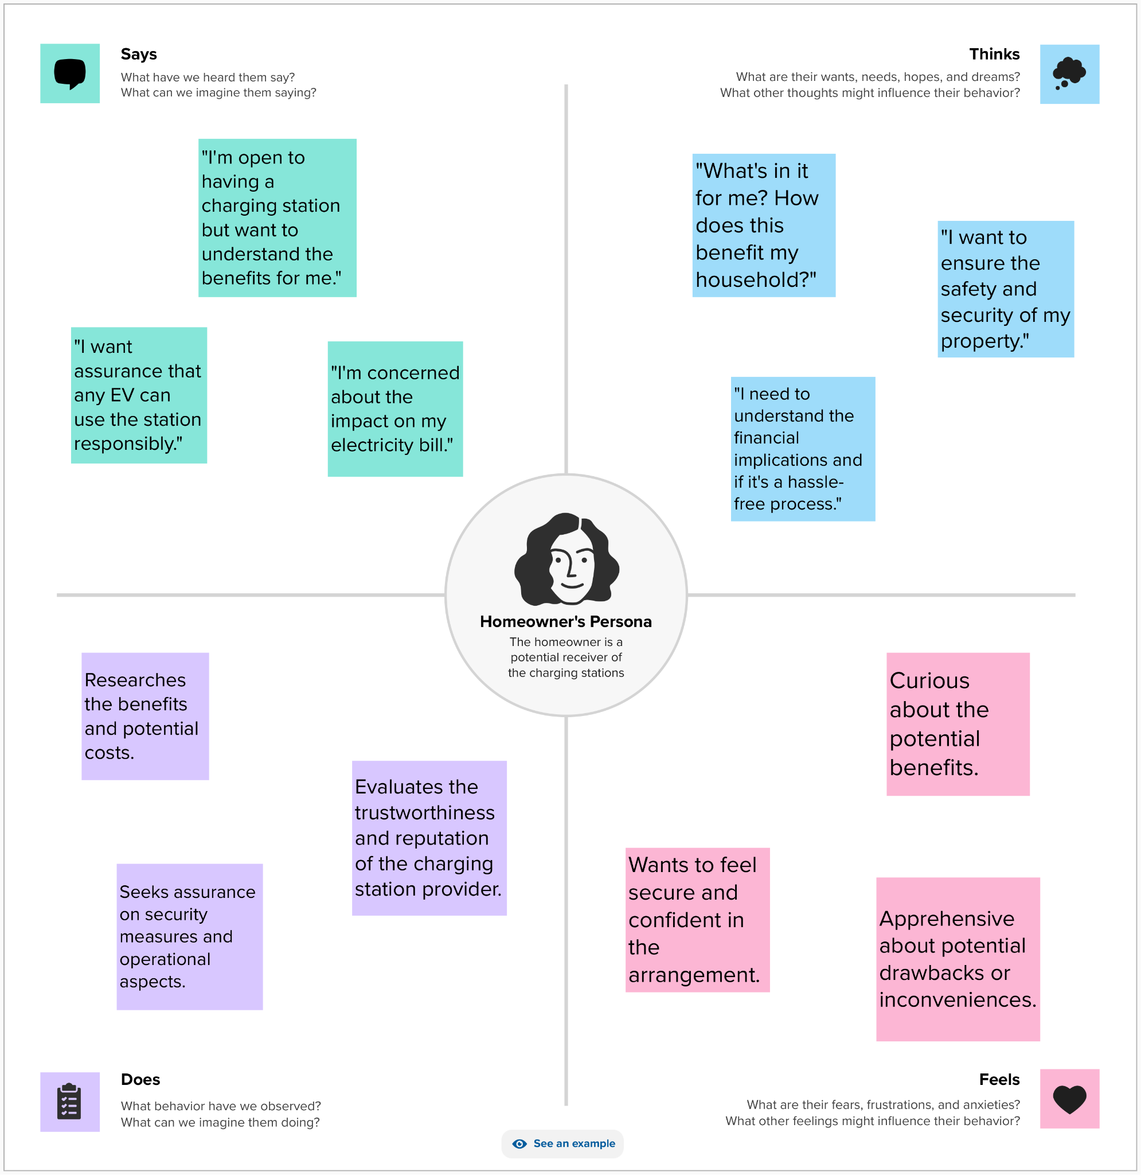

*3.1.2 EV Owner’s Persona*

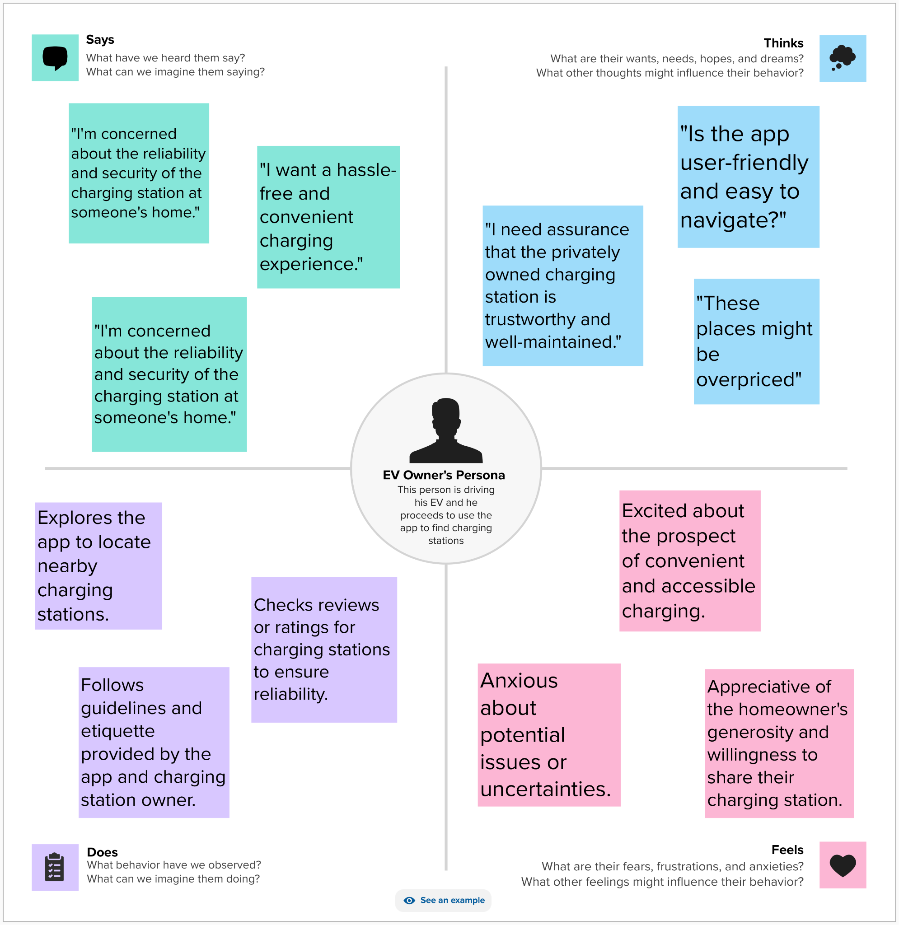

1. **Novelty/ Uniqueness**

Our distinctive business model ingeniously transforms residential spaces into EV charging hubs, mitigating the impending shortage of charging stations in India. Collaborating with EV manufacturers, we utilize untapped private spaces, converting them into profit-sharing charging stations. Users enjoy a seamless experience through a smart app, factoring in vehicle specifics and route analysis. Homeowners earn a share of profits proportional to user traffic. This approach not only optimizes unused spaces but also fosters a community-driven, scalable solution, aligning with the surge in India's EV industry while providing a sustainable and lucrative avenue for both users and space owners alike.

We use ML to train a dataset using Random Forest model to display the optimum location of the charging space for the vehicle irrespective of the distance it has to cover and the battery percentage displayed at that time.

1. **Social Impact/Customer Satisfaction**

The business model discussed carries significant social impact and customer satisfaction:

***5.1 Community Integration:***

Fosters a sense of community engagement by utilizing private spaces within residential areas, encouraging a collaborative effort to address the growing demand for EV charging infrastructure.

***5.2 Sustainable Use of Resources:***

Converts unused spaces into charging stations, promoting sustainability and efficient use of existing resources. This aligns with environmentally conscious practices and contributes to reducing the carbon footprint associated with traditional charging infrastructure.

***5.3 Financial Empowerment for Homeowners:***

Provides homeowners with an opportunity to earn a share of profits, fostering financial empowerment and incentivizing participation in the initiative. This economic benefit positively impacts local communities.

***5.4 User-Friendly Experience:***

Enhances customer satisfaction through a user-friendly app that considers various factors such as vehicle models, routes, and charging station viability. This attention to user needs ensures a seamless and efficient charging experience for EV drivers.

***5.5 Convenience for EV Users:***

Offers a convenient and optimized charging experience for EV users by providing a comprehensive charging plan through the app. This not only saves time for users but also contributes to a positive perception of electric vehicle adoption.

***5.6 Scalable and Inclusive Solution****:*

Presents a scalable solution to the shortage of EV charging stations, accommodating the exponential growth of the EV industry in India. The inclusive nature of the model ensures that a wide range of homeowners and EV users can participate, contributing to its widespread impact.

***5.7 Positive Industry Influence:***

Influences positively the electric vehicle industry by addressing infrastructure challenges, potentially encouraging further adoption of electric vehicles with the assurance of accessible and convenient charging solutions.

In summary, this business model has the potential to create a positive social impact by engaging communities, promoting sustainability, empowering homeowners, and enhancing the overall satisfaction of EV users, contributing to the advancement of the electric vehicle ecosystem in India.

**6. Business Revenue generation model**

*6.1 Energy Consumption Fee:*

* + **Description:** Charge users based on the amount of electricity consumed during their charging session.
  + **Revenue Generation:** Revenue is generated by calculating the cost per unit of electricity consumed during the charging process.

*6.2 Occupancy Time Fee:*

* + **Description:** Charge users for the time spent occupying the charging spot, encouraging prompt departure after the charging session is complete.
  + **Revenue Generation:** Revenue is generated by calculating the cost per unit of time the user's vehicle occupies the charging spot.

*6.3 Variable Pricing:*

* + **Description:** Implement variable pricing based on peak and off-peak hours, with higher rates during times of high demand and lower rates during periods of lower demand.
  + **Revenue Generation:** Users pay different rates depending on the time of day, optimizing revenue during peak usage periods.

*6.4 Subscription Plans:*

* + **Description:** Offer subscription plans for regular users, providing benefits such as discounted energy rates, reduced occupancy time fees, or priority access to charging spots.
  + **Revenue Generation:** Generate recurring revenue through subscription fees paid by users who opt for premium plans.

*6.5 Penalties for Overstaying:*

* + **Description:** Implement penalty fees for users who exceed a predetermined maximum occupancy time to incentivize timely departure.
  + **Revenue Generation:** Additional revenue is generated when users exceed the allowed time, encouraging turnover at charging stations.

*6.6 Promotional Partnerships:*

* + **Description:** Collaborate with local businesses to offer discounts or promotions to users who charge their vehicles at specific locations, creating a mutually beneficial partnership.
  + **Revenue Generation:** Generate revenue through partnerships and advertising deals with businesses featured in promotional offers.

This revenue model is designed to capture income from multiple aspects of the user experience, including energy consumption, time occupancy, subscription plans, partnerships, and premium features, ensuring a diversified and sustainable source of revenue for your EV charging station platform.

**7. Scalability**

***7.1 Technology-Driven Operations:***

Leverage technology for automated processes, remote monitoring, and efficient management of charging stations. A technology-driven approach allows for centralized control and monitoring, reducing the need for extensive on-site personnel.

***7.2 Strategic Partnerships:***

Form strategic partnerships with EV manufacturers, local governments, and businesses. Such partnerships can facilitate the quick deployment of charging stations, leveraging existing infrastructure and networks for accelerated growth.

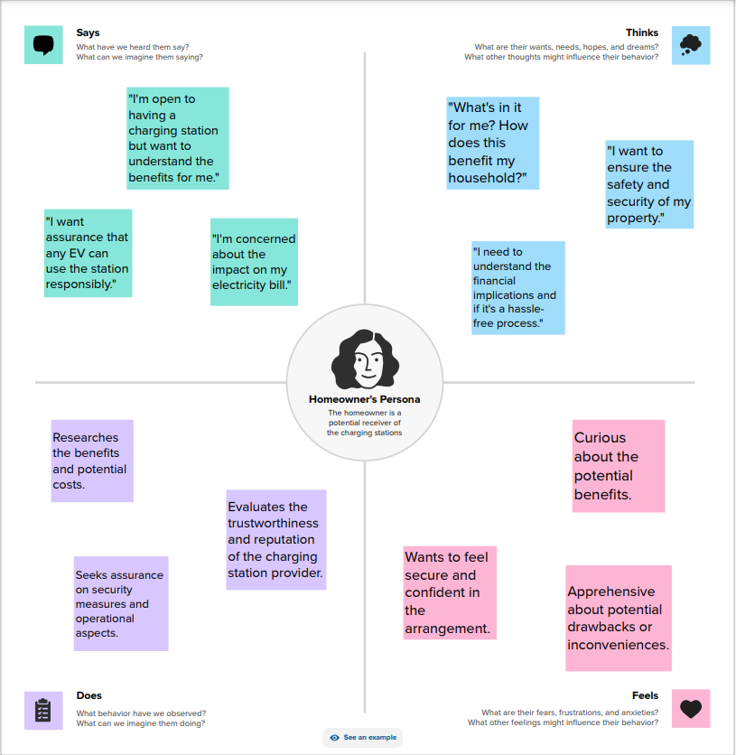

***7.3 Remote Maintenance and Support:***

Implement remote monitoring and maintenance capabilities for the charging infrastructure. Remote diagnostics and support reduce the need for physical intervention, enabling the management of a larger network of charging stations with minimal on-site personnel.

*7****.4 Continuous Innovation:***

Foster a culture of continuous innovation to stay ahead of technological advancements and industry trends. Embracing emerging technologies and business models ensures the scalability of the business in a rapidly evolving market.

**8. References**

[1] Bharadwaj, R. (n.d.). EV infrastructure in India: What to expect by 2030 - Bolt Earth. Bolt Earth.<https://bolt.earth/blog/indian-ev-charging-infrastructure-by-2030>

[2] Energy, E. C. (2023, December 5). Pros and Cons of Charging Electric cars at Home vs. Public Charging Stations. Energy5.<https://energy5.com/pros-and-cons-of-charging-electric-cars-at-home-vs-public-charging-stations>

[3] Energy, E. C. (2023a, August 18). The role of mobile apps in enhancing the EV charging corridor user experience. Energy5.<https://energy5.com/the-role-of-mobile-apps-in-enhancing-the-ev-charging-corridor-user-experience>

[4] Energy, E. C. (2023b, December 1). Sustainable Transportation infrastructure A solution for aging infrastructure challenges. Utilities One.<https://utilitiesone.com/sustainable-transportation-infrastructure-a-solution-for-aging-infrastructure-challenges>

[5] Kabra, A., & Kabra, A. (2023, October 4). Indias EV charging stations: Opportunities and challenges amid rising awareness about electric vehicles. Firstpost.<https://www.firstpost.com/opinion/indias-ev-charging-stations-opportunities-and-challenges-amid-rising-awareness-about-electric-vehicles-13202502.html>

[6] Argue, C. (2023, November 22). Charging EVs at home: Key considerations for fleets. Geotab.<https://www.geotab.com/blog/charging-evs-at-home/>

[7] Chandar, G. (2022b, December 19). Case study: A car charging mobile app for the EV users. Medium.<https://bootcamp.uxdesign.cc/case-study-a-car-charging-mobile-app-for-the-ev-users-79e2b112a5d6>

[8] Sustainable transportation and fuels. (n.d.). Energy.gov.<https://www.energy.gov/eere/sustainable-transportation-and-fuels>

[9] Anuradha. (2021, September 27). EV Charging Infrastructure in India - current status, challenges and way forward • EVreporter. EVreporter.<https://evreporter.com/ev-charging-infrastructure-india-status-challenges/>

[10] Energy, E. C. (2023c, December 5). Evaluating the affordability of Home-Based EV charging systems. Energy5.<https://energy5.com/evaluating-the-affordability-of-home-based-ev-charging-systems>

[11] Sachan, S., & Singh, P. P. (2022). Charging infrastructure planning for electric vehicle in India: Present status and future challenges. Regional Sustainability, 3(4), 335–345.<https://doi.org/10.1016/j.regsus.2022.11.008>

[12] Yang, M., Zhang, L., Zhao, Z., & Wang, L. (2021). Comprehensive benefits analysis of electric vehicle charging station integrated photovoltaic and energy storage. Journal of Cleaner Production, 302, 126967. <https://doi.org/10.1016/j.jclepro.2021.126967>